How to Do a Speed Sort

- Take out your cards.

- Shuffle the cards.
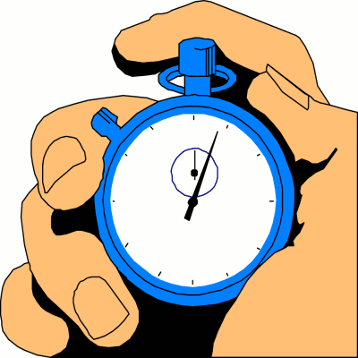

- Get your watch ready. Set it to zero.

- Press start and begin sorting your cards.

- When you finish sorting, press stop.

- Record your time on your progress chart.

- Try again to see if you can get a better time.

- Record your new time and calculate the difference.

- Put your cards back in the envelope.

